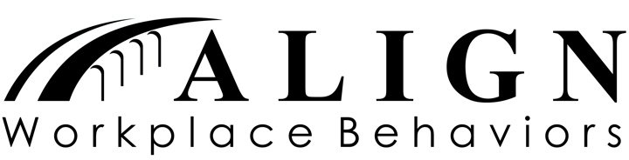

Recommended Reading List for Effective Communication

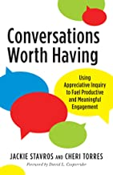
Conversations Worth Having by Jackie Stavros and Cheri Torres share that conversations are at the core of how we interact. We all know that conversations influence us, but we rarely stop to think about how much impact they have on our well-being and our ability to thrive. This book shows how Appreciative Inquiry (AI), one of the most widely used new approaches for fostering positive change for individuals, groups, organizations, and communities, can help everyone communicate better and flourish in all areas of their lives.

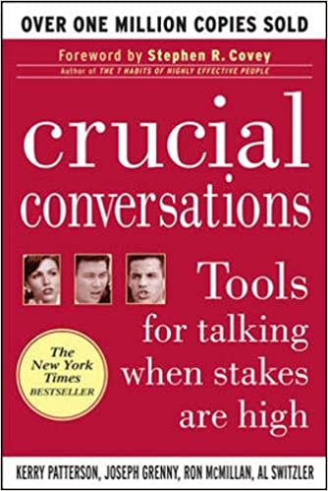
Crucial Conversations by Patterson, Grenny, McMillan and Switzler examine crucial conversations. When stakes are high, opinions vary, and emotions run strong, the authors believe you have three choices: Avoid a crucial conversation and suffer the consequences; handle the conversation badly and suffer the consequences or discover how to communicate best when it matters most. Crucial Conversations gives you the tools you need to step up to life's most difficult and important conversations, say what's on your mind, and achieve the positive resolutions you want.

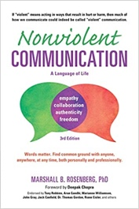
Nonviolent Communication by Marshall Rosenberg, Ph.D. book looks at four things:
1. Consciousness: a set of principles that support living a life of compassion, collaboration, courage, and authenticity
2. Language: understanding how words contribute to connection or distance
3. Communication: knowing how to ask for what we want, how to hear others even in disagreement, and how to move toward solutions that work for all
4. Means of influence: sharing “power with others” rather than using “power over others”

